Smytten E-Commerce Database Management System
CHAPTER – 5
PRODUCT AND CATEGORY MANAGEMENT SYSTEM
Introduction
The Smytten E-Commerce Database Management System is designed to manage product and category information efficiently. The system uses two related tables, Category and Product, to store and organize product details. Primary key and foreign key constraints are used to maintain data integrity. SQL operations such as insertion, updating, and deletion are performed on the Product table. A category-wise product report is generated using SQL and PL/SQL to analyze the products available under each category.
2. Objectives
- Design tables for Product and Category entities.
- Define primary and foreign key relationships.
- Store product name, category, price and stock.
- Perform product insertion, updating and deletion.
- Generate category-wise product reports using SQL and PL/SQL.
3. Table Design

3.1 Category2 Table

Attribute | Data Type | Key | Description
Category_ID | NUMBER | Primary Key | Unique category identifier
Category_Name | VARCHAR2(100) | - | Product category name
3.2 Product2 Table
Attribute | Data Type | Key | Description
Product_ID | NUMBER | Primary Key | Unique product identifier
Product_Name | VARCHAR2(100) | - | Product name
Price | NUMBER (10,2) | - | Product price
Stock | NUMBER | - | Available quantity
Category_ID | NUMBER | Foreign Key | References Category2(Category_ID)

4. Relationship
Category and Product have a one-to-many (1:M) relationship. One category can contain many products, while each product belongs to one category.
CATEGORY (1) ─────────── (M) PRODUCT
Category_ID (PK) Category_ID (FK).
5. SQL Table Creation
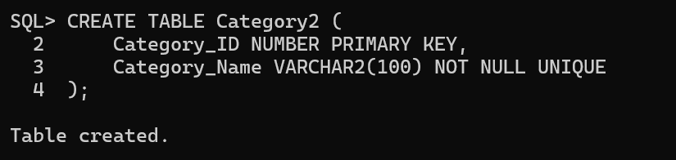
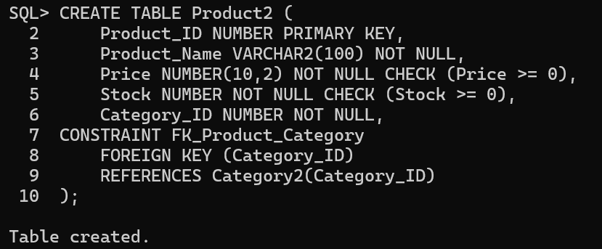
6. Insert Records
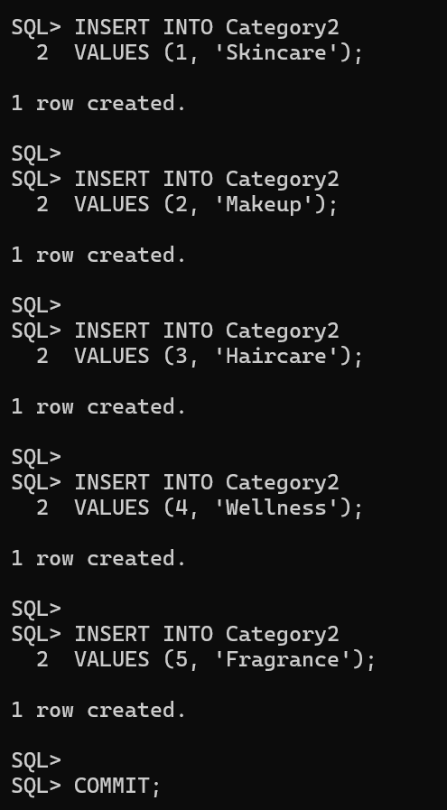
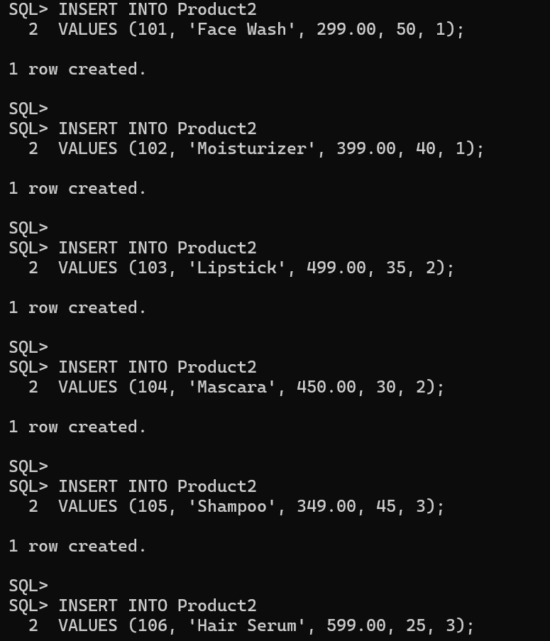
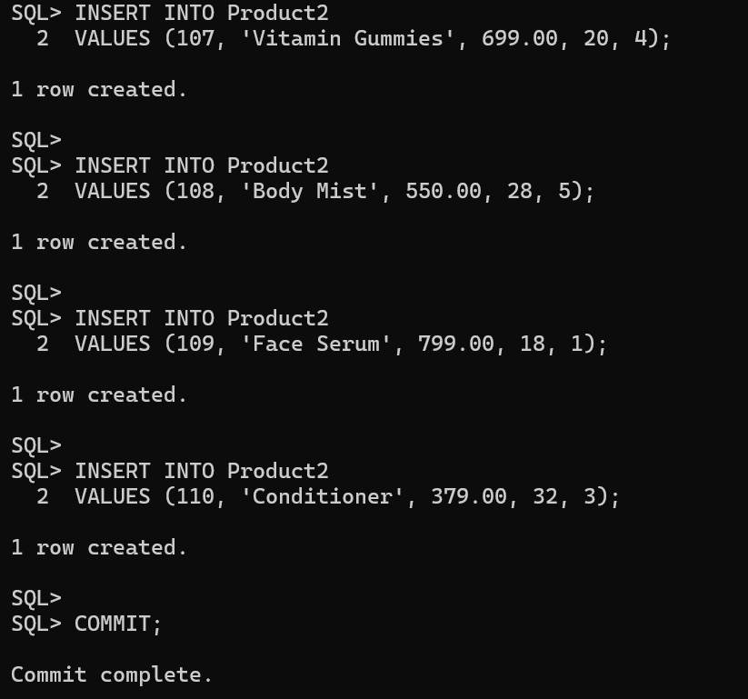

7. Product Insertion, Updating and Deletion
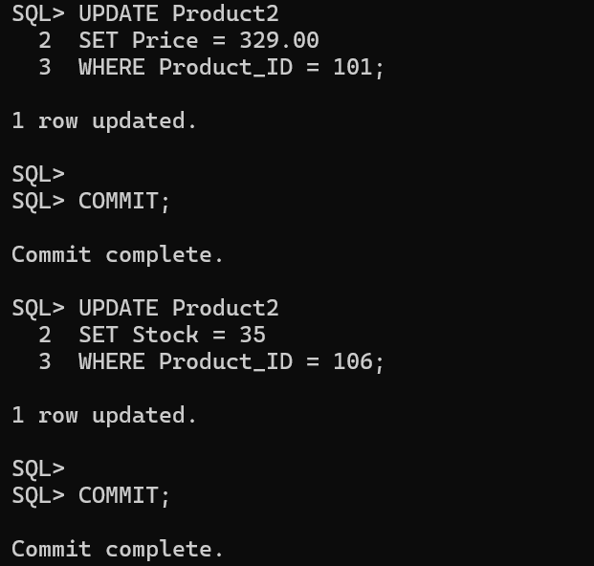
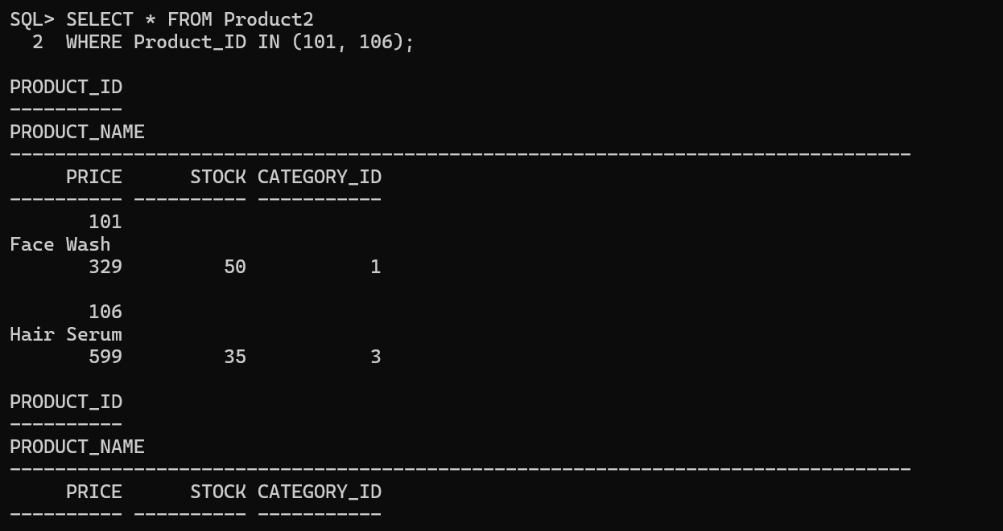
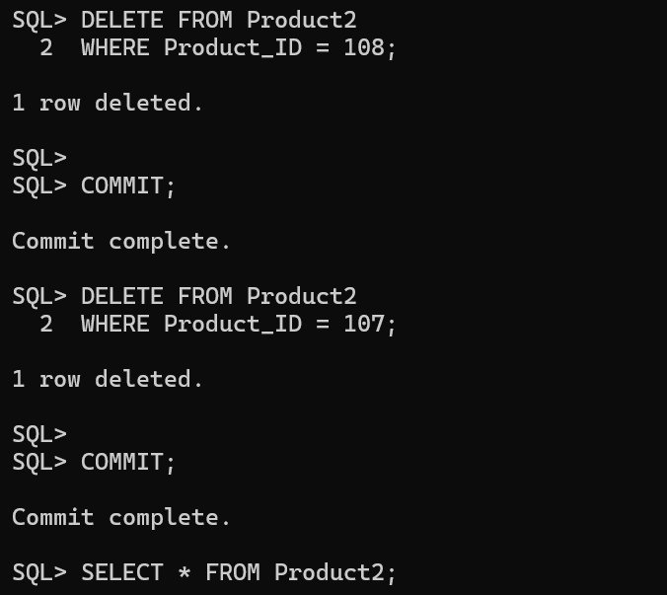
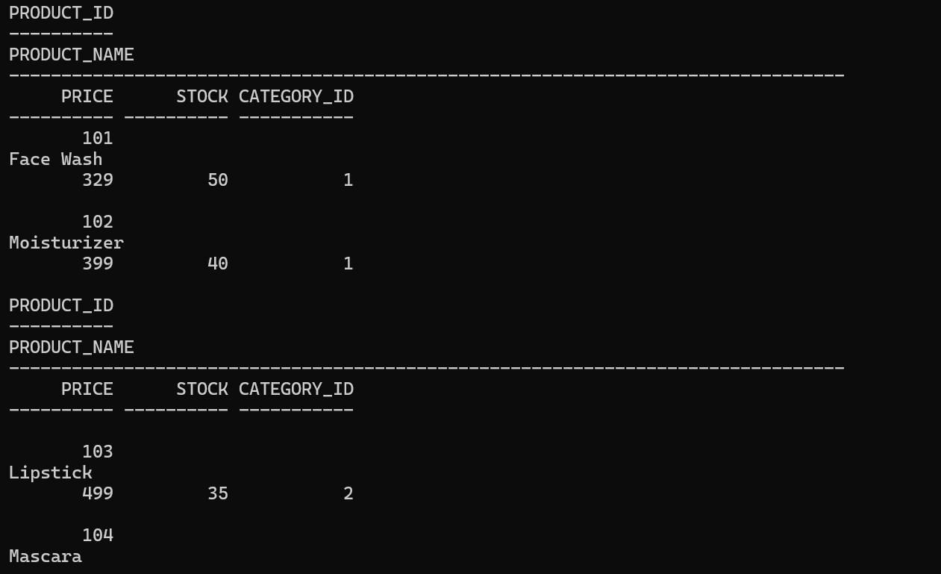

8. Category-wise Product Report (SQL)
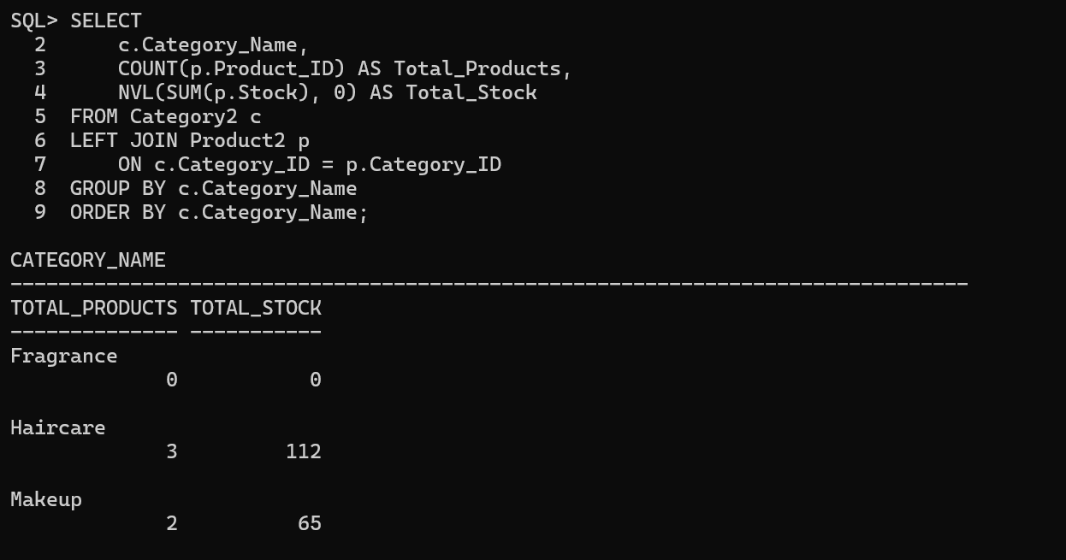

9. PL/SQL Program – Category-wise Report
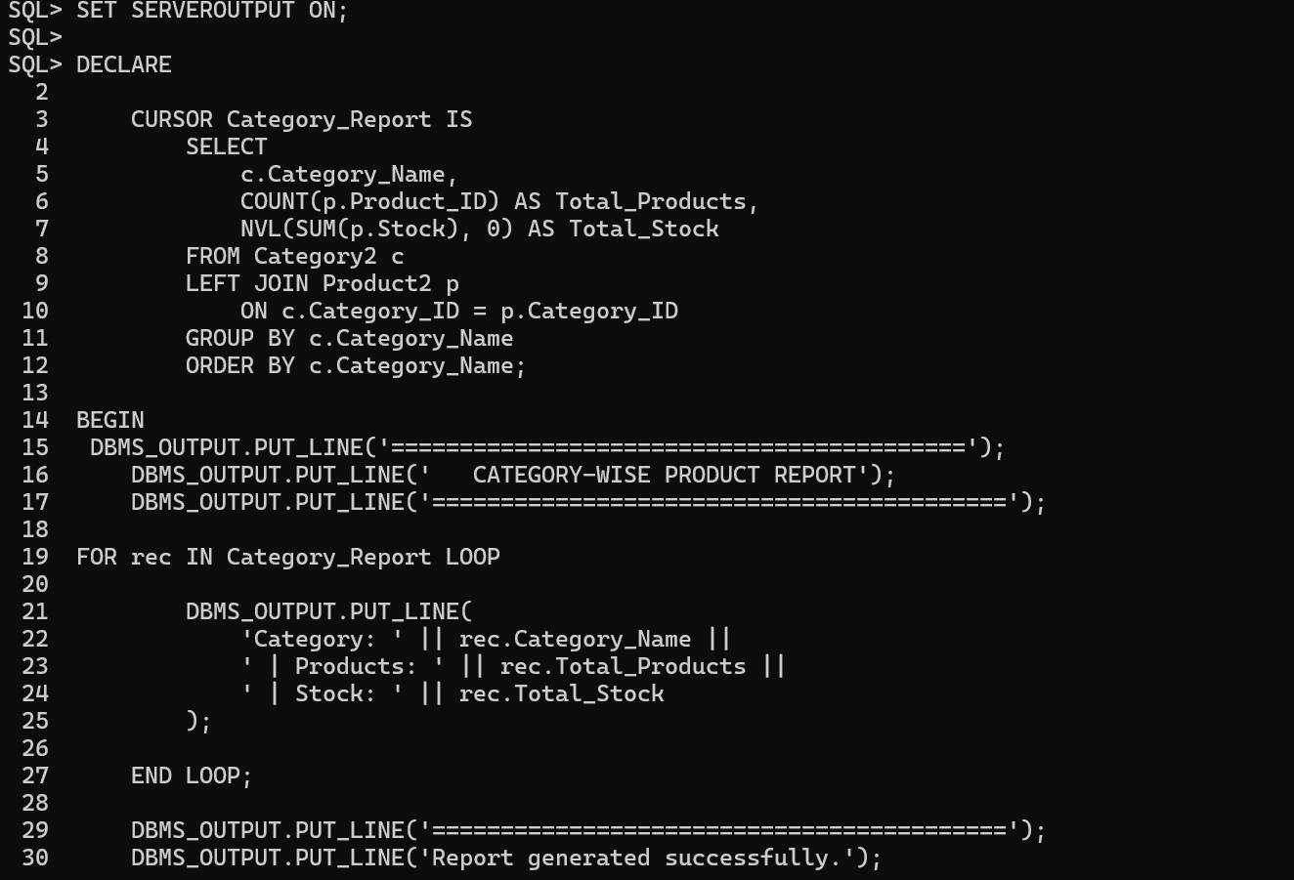

10. PL/SQL Program – Product Price Update
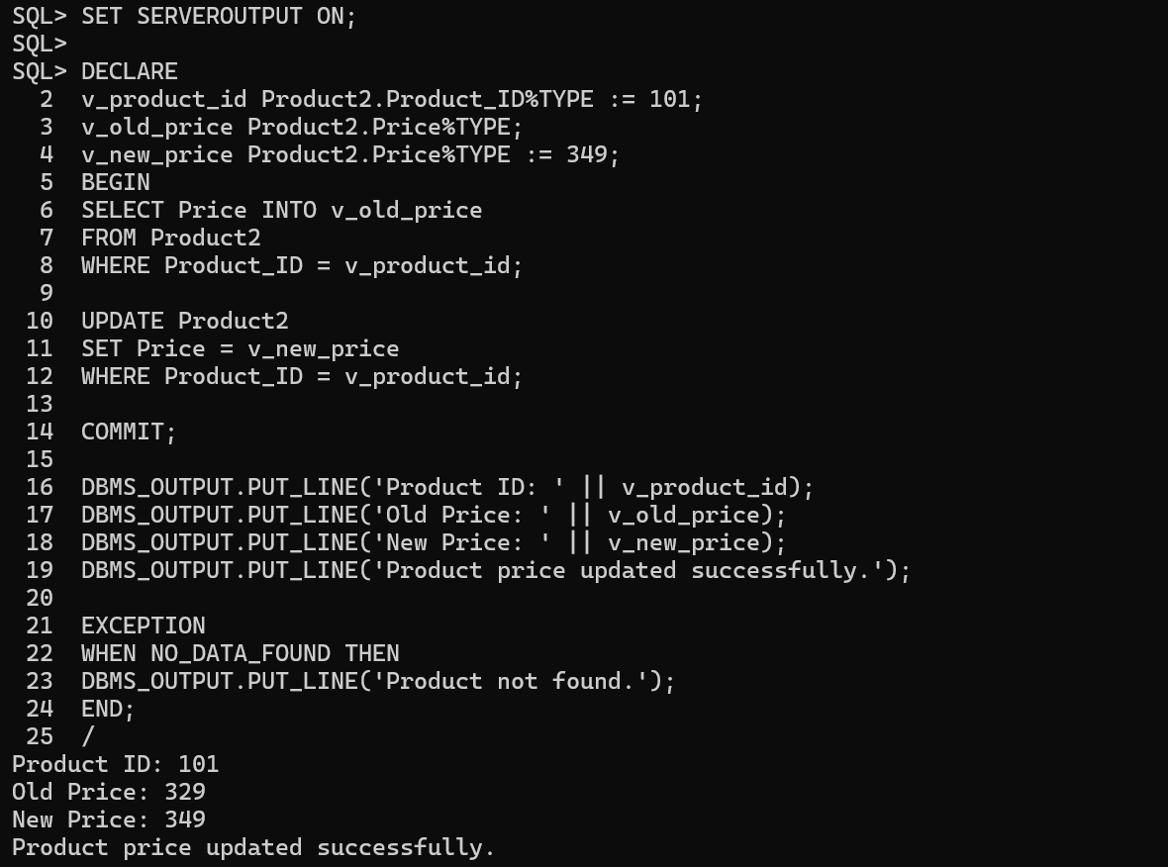

11. Expected Category-wise Report
Category | Total Products | Total Stock
Fragrance | 1 | 28
Haircare | 3 | 102
Makeup | 2 | 65
Skincare | 3 | 108
Wellness | 1 | 20
12. Conclusion
The Product and Category database design successfully represents the one-to-many relationship between categories and products. Primary and foreign key constraints maintain data integrity, while INSERT, UPDATE and DELETE operations support product management. The category-wise report provides a useful summary of products and stock. The PL/SQL cursor program demonstrates procedural database programming for report generation.

